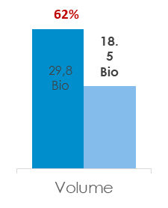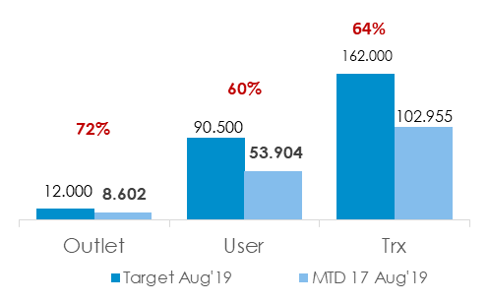

Volume

(data terakhir)

Nilai + grafik line

Transaction

(data terakhir)

Nilai + grafik line

Active user

(data terakhir)

Nilai + grafik line

Active outlet

(data terakhir)

Nilai + grafik line

Maret

View Data Bln

Search by bln

Feb

Jan

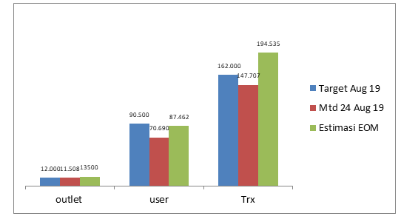

Target MTD (bulanan)

View Data Tgl

Search by tgl

Target Daily

Hasil Analisa

Hasil Analisa

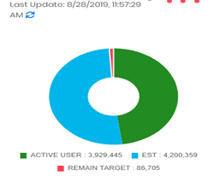

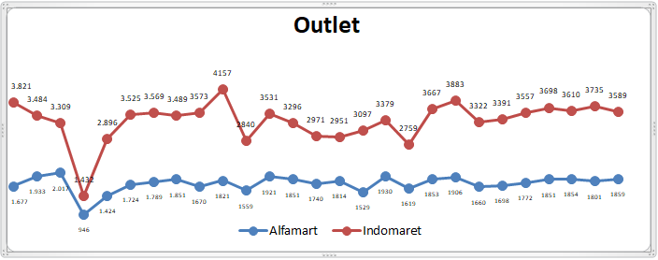

Di buat masing2 outlet, user trx dan volume perdata harian



Volume vs target

Trx vs target

Outlet vs target

User vs target

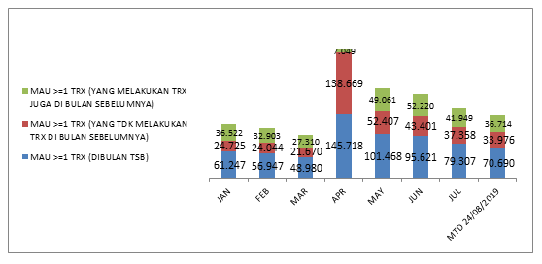

View Data

Target MAU Retention

Contoh pencarian data with excel nya

1. Untuk pencarian data harian masing2 user, outlet, trx, volume

|  |  |  |  |  |  |  |  |  |  |  |  |
| --- | --- | --- | --- | --- | --- | --- | --- | --- | --- | --- | --- |
| Outlet | 01-Aug | 02-Aug | 03-Aug | 04-Aug | 05-Aug | 06-Aug | 07-Aug | 08-Aug | 09-Aug | 10-Aug | 11-Aug |
| Alfamart | 1.677 | 1.933 | 2.017 | 946 | 1.424 | 1.724 | 1.789 | 1.851 | 1670 | 1821 | 1559 |
| Indomaret | 3.821 | 3.484 | 3.309 | 1.432 | 2.896 | 3.525 | 3.569 | 3.489 | 3573 | 4157 | 2840 |

1. Mencari Target Daily dan diagram pie

|  |  |  |  |
| --- | --- | --- | --- |
|  | Target Aug 19 | Mtd 24 Aug 19 | persentase |
| outlet | 12.000 | 11.508 | 96% |
| user | 90.500 | 70.690 | 78% |
| Trx | 162.000 | 147.707 | 91% |
| Volume | 29.800.000.000 | 26.726.668.522 | 90% |

1. Mencari Mau Retention

|  |  |  |  |  |  |  |
| --- | --- | --- | --- | --- | --- | --- |
| **Modern Channel** | **JAN** | **FEB** | **MAR** | |  | | --- | | **APR** | | **MAY** |
| MAU >=1 TRX (DIBULAN TSB) | 61.247 | 56.947 | 48.980 | 145.718 | 101.468 |
| MAU >=1 TRX (YANG TDK MELAKUKAN TRX DI BULAN SEBELUMNYA) | 24.725 | 24.044 | 21.670 | 138.669 | 52.407 |
| MAU >=1 TRX (YANG MELAKUKAN TRX JUGA DI BULAN SEBELUMNYA) | 36.522 | 32.903 | 27.310 | 7.049 | 49.061 |